**CIVIL RIGHTS**

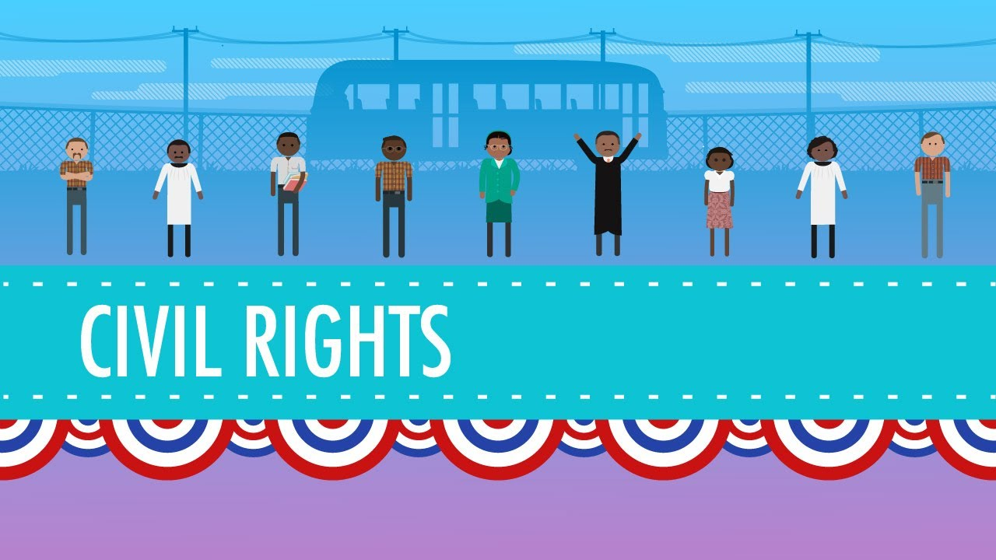Civil rights have changed dramatically over the years as the information age progresses. The internet is being used for people to express their views, now that we have freedom of speech, anyone is allowed to express their thoughts and views on current matters and spreading awareness of pressing issues for example terror threats/attacks from terrorist groups.

* At a ***Personal*** level people are able to make others aware of human rights and equality of genders. With the freedom of speech they are able to speak on topics that may be affecting our society. Social websites and newsgroups play a big role as many people express themselves and get feedback.
* With the internet we’re able to get all the information civil rights to know what is just and what isn’t.
* ***Socially*** people are able to bring up matters for example the issue of gay rights and how they should be shown equality. In the year 2015 the whole of the United States of America became a haven for the gay couples because they were allowed to marry the same sex “same-sex-marriage”. With the awareness of these laws people are able to appreciate and accept the gay community without discrimination. No matter your location all rights will be available online.
* Our lives ***Professionally*** have not been affected that much. We can probably conclude that at work places people are more aware of the right s they have and the equality they should receive from the firm they are working at. With the newly approved law that was passed in America, which is th acceptance of gay people in the community and also legal marriage, anyone no matter their gender preferences they are allowed to hold a position at any office without discrimination.